Social Media Marketing Agency for Small Businesses: What to Look For
Meta Title: How to Pick the Right Social Media Agency for SMBs (Ch–50)
Meta Description: Hiring a social media marketing agency for your small business? Learn the 9 key things to look for before you sign, so your budget actually drives growth. (Ch–154)
Focus Keyword: social media marketing agency
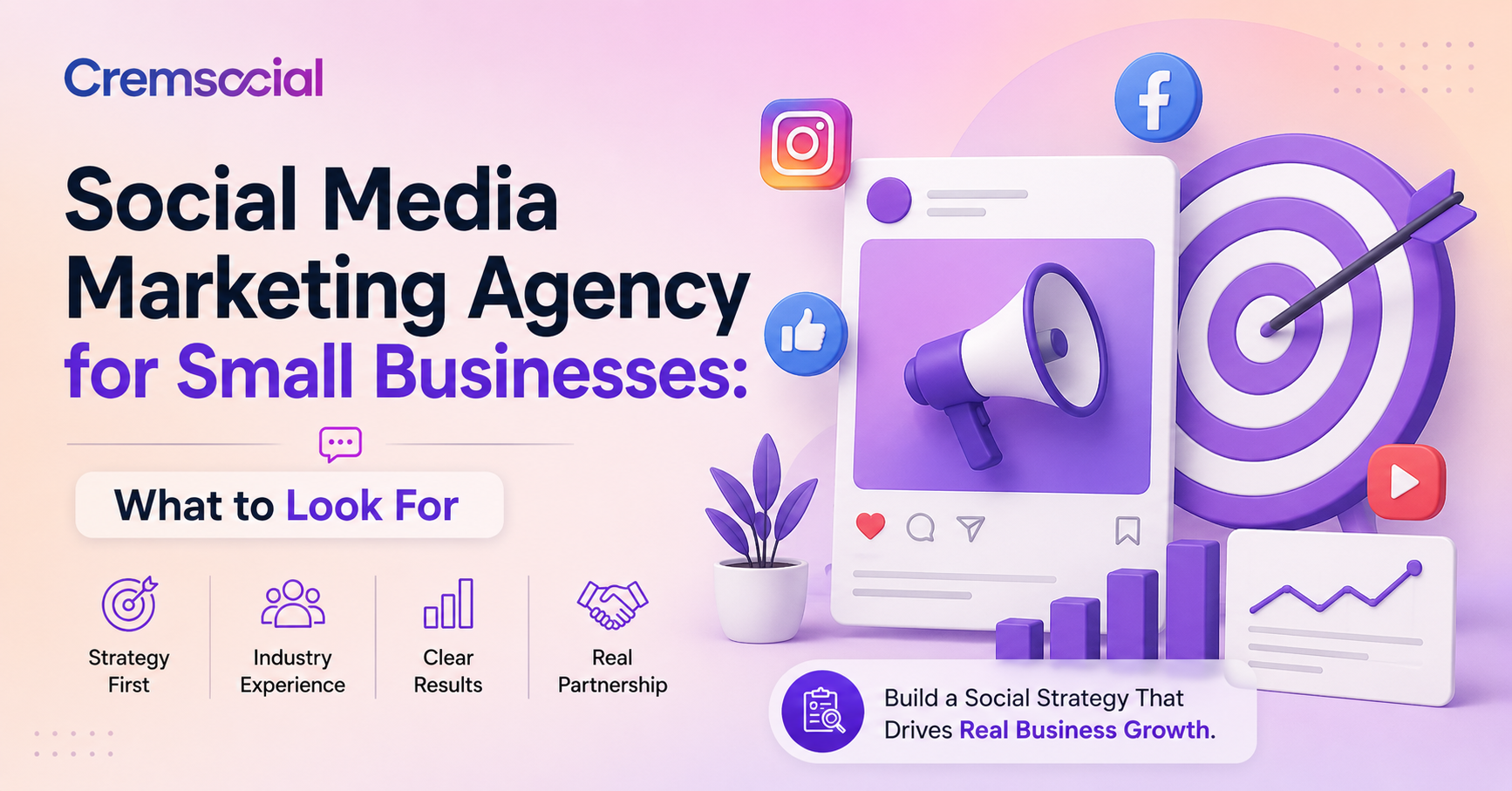
Social media has become one of the most affordable ways for a small business to reach new customers, but running it well takes more time and skill than most owners have to spare. That's usually the point where hiring a social media marketing agency starts to make sense. The problem is that the industry is full of agencies promising "growth" and "engagement" without ever explaining how that connects to actual sales.
If you're evaluating agencies for the first time, it helps to know exactly what separates a partner who will move your business forward from one who will just keep you busy with posts. Here's what to look for.

Why Small Businesses Struggle to Manage Social Media Alone
Most small business owners already wear five or six hats - sales, operations, customer service, and everything in between. Social media then becomes something squeezed in between real work: a caption written in a rush, a photo posted without a plan, weeks of silence when things get busy. The result is usually inconsistent posting, no clear strategy behind what's being shared, and no way to tell whether any of it is actually bringing in customers.
An agency's job is to remove that guesswork. Done well, social media marketing should feel less like "another task" and more like a channel that consistently brings in inquiries, bookings, or sales, the same way a good sales rep would.

1. A Strategy Before a Posting Calendar
The first thing to check is whether a social media marketing agency starts with strategy or starts with content. Some agencies will jump straight into designing posts and building a calendar without ever asking who your ideal customer is, what you're trying to achieve, or how social fits into your broader marketing.
A good agency will want to understand your business model, your target audience, your competitors, and what "success" actually looks like for you - more calls, more foot traffic, more online orders - before a single post gets scheduled. If an agency can't clearly explain what the strategy behind your content is, that's a warning sign.

2. Experience With Businesses Like Yours
Social media marketing agencies look very different for a local restaurant than it does for a B2B service company or an e-commerce store. An agency that has worked with businesses similar to yours will already understand the platforms your customers actually use, the type of content that performs in your industry, and the common pitfalls to avoid.
Ask for examples of past work in your industry or a similar one, and look closely at whether their case studies mention actual outcomes - more leads, more bookings, more website traffic - rather than only follower counts.

3. Clear, Honest Reporting
This is one of the biggest differentiators between agencies that deliver value and agencies that just look busy. Likes, followers, and impressions are easy numbers to report, but they don't tell you whether social media is actually growing your business.
Look for an agency that reports on the metrics that matter: website clicks, form submissions, DMs, calls, and - where possible - how those connect back to actual revenue. If an agency's monthly report is just a screenshot of vanity metrics with no explanation of what it means for your bottom line, that's a sign the strategy behind it may be just as thin.

4. Content That Sounds Like Your Business, Not a Template
A lot of agencies run the same content playbook across every client - the same style of graphics, the same generic captions, the same posting cadence - regardless of the business. Customers can usually tell when a brand's social presence feels generic rather than authentic.
A strong agency will take the time to understand your brand voice and build content pillars specific to your business, so your profile actually sounds like you and speaks directly to the people you're trying to reach, rather than reading like stock content dropped into your account.

5. Platform Expertise Where Your Customers Actually Are
Not every platform deserves equal attention. A B2B marketing company may get far more value from LinkedIn than TikTok, while a local retail business might see the opposite. An agency that pushes you onto every platform at once, rather than focusing on where your specific audience spends time, is often optimizing for their own workload rather than your results.
Ask which platforms they'd recommend for your business specifically, and why. A thoughtful answer here is usually a good signal of how they'll approach the rest of the strategy.

6. Transparent Pricing With No Hidden Surprises
Small business budgets are tighter than enterprise budgets, and pricing needs to reflect that. Look for agencies that are upfront about what's included in a package - content creation, scheduling, community management, paid promotion, reporting - rather than vague retainers with unclear deliverables.
It's also worth asking what happens if results aren't showing up. A trustworthy agency should be willing to explain how they'll adjust the approach, not just keep billing the same retainer regardless of performance.

7. Real Communication, Not Just Automated Updates
You should be able to reach a real person when you have a question, see a new opportunity, or need to pivot quickly around a promotion or event. Agencies that disappear between monthly reports, or that route every question through a slow ticketing system, make it hard to stay agile - and social media often rewards businesses that can move fast.
Ask how communication actually works day to day: Is there a dedicated point of contact? How quickly do they typically respond? Can you request changes outside of the regular reporting cycle?

8. No Long-Term Lock-In Without Proof
Some agencies push clients into long annual contracts before they've proven any results. For a small business testing whether a social media marketing agency is the right fit, that kind of commitment can be risky. Look for agencies that offer a reasonable trial period or month-to-month flexibility, at least until you've seen enough performance data to feel confident in the partnership.

9. A Focus on Growth You Can Actually Feel
At the end of the day, the best sign of a good social media marketing agency isn't how polished their pitch deck looks - it's whether the work translates into something you can feel in your business. More calls. More bookings. More people are walking through the door because they saw you online. If a social media marketing agency can't draw a clear line between their work and that kind of outcome, it's worth asking harder questions before signing on. This is often where a broader digital marketing agency approach helps, since social media rarely works in isolation from SEO, ads, and your website.

Questions Worth Asking Before You Hire
- What's your strategy process before you start creating content?
- Can I see examples of results for businesses similar to mine?
- What metrics will I see in my monthly report, and how do they tie to revenue?
- Which platforms do you recommend for my business, and why?
- What's included in my package, and what costs extra?
- Who will I be talking to day to day?
- What happens if performance isn't where we want it to be?
A confident, specific answer to each of these is usually a good sign. Vague or evasive answers are worth taking seriously as a red flag.

Final Thoughts
Social media marketing can be one of the highest-value channels available to a small business, but only when it's handled by people who treat it as a growth strategy rather than a content-scheduling service. The agencies worth hiring are the ones who start with your business goals, report on outcomes that actually matter, and are honest with you about what's working and what isn't.
At Cremsocial, this is exactly the approach we take with small businesses and creators across the GTA. We build social media marketing strategies around clicks, replies, DMs, and actual business growth - not vanity numbers and we'll tell you honestly if something isn't working rather than hide behind a busy-looking report. If you're evaluating agencies and want a straightforward second opinion, get a free marketing audit from Cremsocial and see exactly where your social media stands.

FAQs
1. How much does a social media marketing agency cost for a small business?
Pricing varies widely depending on what's included, but most small business packages range from a few hundred to a few thousand dollars per month based on content volume, platforms managed, and whether paid promotion is included. Rather than comparing agencies on price alone, ask exactly what's covered in the retainer - content creation, community management, and reporting can all be priced separately, and a lower monthly fee sometimes means fewer deliverables.
2. What's the difference between a social media marketing agency and a freelancer?
An agency typically offers a full team - strategist, content creator, and account manager - along with more structured reporting and platform expertise across multiple industries. A freelancer can be a more affordable option for very small budgets, but may lack the same depth of strategy, backup coverage during time off, or access to broader services like paid ads and SEO that a full-service digital marketing agency can provide alongside social.
3. How long does it take to see results from a social media marketing agency?
Most small businesses start seeing measurable engagement and traffic within 4 to 8 weeks, but real business outcomes - leads, bookings, or sales tied to social - usually take 3 to 6 months to show up consistently. Be wary of any agency promising overnight results; sustainable growth on social media comes from consistent strategy and content, not quick wins.
4. What metrics should a social media marketing agency report on?
Beyond likes and followers, a good agency should report on metrics tied to your business goals - website clicks, form submissions, DMs, calls, and how those connect back to actual revenue. If a monthly report only shows vanity metrics like impressions and follower growth with no explanation of business impact, it's a sign the strategy behind it may not be tied to real outcomes.
5. Do I need a different social media strategy for each platform?
Yes. Each platform attracts a different audience and rewards different content formats - what performs on Instagram won't necessarily work on LinkedIn or TikTok. A good social media marketing agency will recommend the platforms where your specific customers actually spend time, rather than pushing you to maintain a presence everywhere at once.
6. Should I sign a long-term contract with a social media marketing agency?
Not necessarily, especially if it's your first time hiring one. Look for agencies offering a reasonable trial period or month-to-month flexibility so you can evaluate real performance before committing long-term. Agencies confident in their results usually don't need to lock clients into lengthy contracts to prove their value.
7. Can a social media marketing agency help with other marketing like SEO or ads?
Many agencies, including full-service ones, offer social media alongside complementary services like SEO, paid ads, and Google Business Profile management, since these channels tend to perform better together than in isolation. If your agency only handles social media, it's worth asking how they coordinate with your other marketing efforts — or whether working with a broader digital marketing agency might drive stronger, more connected results.

